Financial Mathematics – Lesson 1.03
Earning & Managing Money - Wages

Name: _________________

- What job would you like? Remember that even if you are not qualified there are many jobs that will support that occupation.

Go to
www.industrialrelations.nsw.gov.au/NSW_State_Awards/Which_award.html

______________________

- What is the pay rate for that award?

$ _______________

- Calculate how much they earn for a:

  - 40 hour week.

Weekly Pay = ________ x 40 hours = $ ____ . __

  - 35 hour week.

Weekly Pay = ________ x __ = $

  - 38 hour week.

Weekly Pay = = $ ____ . __

Exercises: (Show labels and working)

- Bill earns $37/hr. How much is he paid for a 35 hour week?

- Marge works a 38 hour week. She is paid $17.50/hr. How much does she earn?

- George is paid $50 an hour for a 40 hour work. What is his net pay?

- Who earns the most?

a) George works for 20 hours at $19.50/hr.

b) Mary works for 18 hours at $21/hr.

5. Complete the table by calculating the missing amounts.
Earnings | Hours | Hourly Rate
 | 39 | $14
$385 |  | $19
$950 | 40
 | 35 | $1 7.80
$406.50 |  | $11.25
$2037.40 | 38

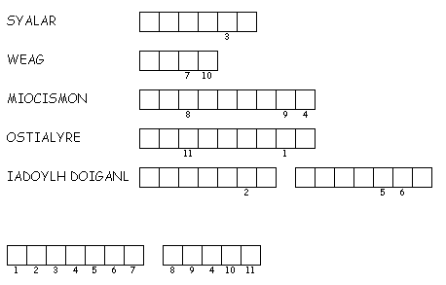
6. Unscramble each of the clue words.

Copy the letters in the numbered cells to other cells with the same number.

