Financial Mathematics – Lesson 1A.02
Earning & Managing Money - Salary

Name: _________________

- What job would you like? Remember that even if you are not qualified there are many jobs that will support that occupation.

Go to http://content.mycareer.com.au/salary-centre/

______________________

- How much salary do they get paid per annum?

$ _______________

- What does per annum mean?

_____________________________________________________________

- Calculate how much they earn per:
1 Year
= 12 months
= 26 fortnights
= 52 weeks
=365.25 days

  - Month

Monthly Pay = ________ ÷ 12 = $ ____ . __

  - Fortnight

Fortnightly Pay = ________ ÷ __ = $ ____ . __

  - Week

Weekly Pay = = $ ____ . __

Exercises: (Show labels and working)

- Mary earns $24 000 p.a. How much is she paid per month?

- How much does Bill, a vet, get paid per week if he receives an annual salary of $57200. p.a.

- Harry is paid a salary of $130 000 p.a. How much is he paid per fortnight?

- Milly earns $750/week. What is her annual salary?

5. Complete the table:
Annual | Fortnightly | Weekly | Daily
$34 580
 | $812
 |  | $875
 |  |  | $240
 | $1 050
 |  | $2 730

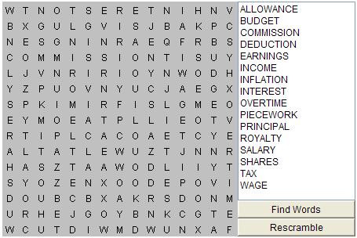

http://www.scriptsocket.com/user/myfindaword.php?sVxB40bLpUZ

Web address of this puzzle.

